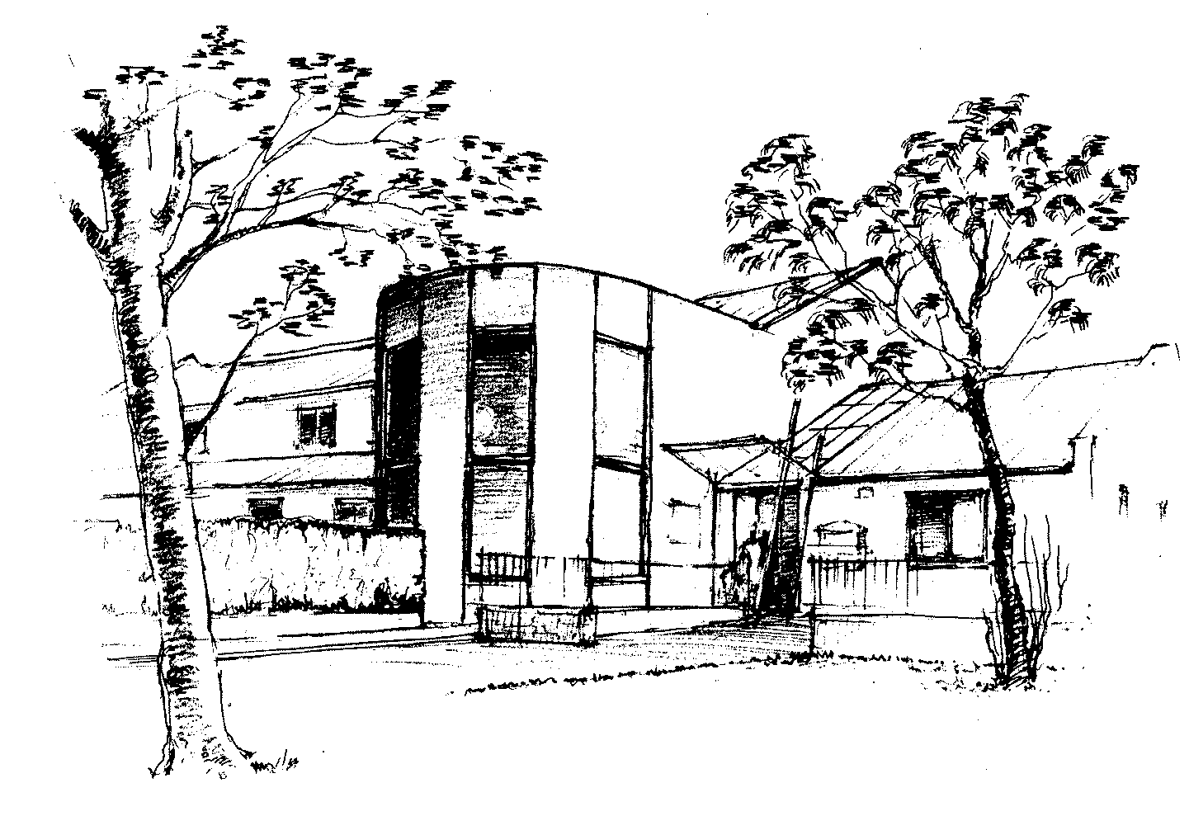
Ladywell Medical Centre East

PATIENT BEHAVIOUR POLICY

Our staff are here to help you. You will be treated with dignity, courtesy and respect at all times. We expect you to behave in the same way.

You are advised that this Practice operates a Zero Tolerance policy for unacceptable behaviour towards all members of staff.

Instances of unacceptable behaviour may result in the Police being called and immediate removal from the Practice list or, depending upon the seriousness of the incident, a behaviour warning letter. In either case an entry will be made in your medical record of the incident.

This Practice considers unacceptable patient behaviour to be:

- Attempted or actual, aggressive, threatening physical actions made towards any member of staff which leads to fear of a staff member’s safety

Or

- The use of aggressive or abusive language, (including raising of the voice, swearing and cursing), which threatens or intimidates or makes any member of staff feel uncomfortable or embarrassed whether face to face or on the telephone

